**Problem Statement 3:**

Calculate F Test for given 10, 20, 30, 40, 50 and 5,10,15, 20, 25.

For 10, 20, 30, 40, 50:

F Test is generally defined as ratio of the variances of the given two set of values. First [calculate standard deviation](https://ncalculators.com/statistics/mean-standard-deviation-calculator.htm) and variation of the given set of values. The formula used to calculate SD is,  
**Standard Deviation Formula**  
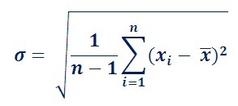  
The standard deviation is represented by the symbol ᵟ and variance is square of the standard deviation.  
The formula used to calculate F Test is,  
**F Test Formula**  
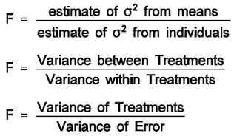

**Calculate Variance of first set**  
  
Total Inputs (N) =(10,20,30,40,50)  
Total Inputs (N)=5  
Mean (xm)= (x1+x1+x2...xn)/N  
Mean (xm)= 150/5  
Means(xm)= 30  
SD=sqrt(1/(N-1)*((x1-xm)2+(x2-xm)2+..+(xn-xm)2))  
=sqrt(1/(5-1)((10-30)2+(20-30)2+(30-30)2+(40-30)2+(50-30)2))  
=sqrt(1/4((-20)2+(-10)2+(0)2+(10)2+(20)2))  
=sqrt(1/4((400)+(100)+(0)+(100)+(400)))  
=sqrt(250)  
=15.8114  
Variance=SD2  
Variance=15.81142  
Variance=250  
  
**Calculate Variance of second set**  
For 5, 10,15,20,25:  
Total Inputs(N) =(5,10,15,20,25)  
Total Inputs(N)=5  
Mean (xm)= (x1+x2+x3...xN)/N  
Mean (xm)= 75/5  
Means (xm)= 15  
SD=sqrt(1/(N-1)*((x1-xm)2+(x2-xm)2+..+(xn-xm)2))  
=sqrt(1/(5-1)((5-15)2+(10-15)2+(15-15)2+(20-15)2+(25-15)2))  
=sqrt(1/4((-10)2+(-5)2+(0)2+(5)2+(10)2))  
=sqrt(1/4((100)+(25)+(0)+(25)+(100)))  
=sqrt(62.5)  
=7.9057  
Variance=SD2  
Variance=7.90572  
Variance=62.5

**To calculate F Test**  
F Test = (variance of 10, 20,30,40,50) / (variance of 5, 10, 15, 20, 25)  
= 250/62.5  
= 4.  
  
**The F Test value is 4.**